***Core Libraries Used & Their Strength, Suitability, & Role in this Project***

**Title: *Agricultural Product Distribution Forecasting: Predicting Demand to Optimize Harvest Schedules***

**🔢 Data Handling and Numerical Computation**

✅ **pandas**  
📌 *Strength*: Powerful DataFrame handling and time-series indexing.  
🎯 *Suitability*: Enabled structured manipulation of sales records, grouped by product and time. Perfect for dataset splitting and rolling forecasts.

✅ **numpy**  
📌 *Strength*: Efficient matrix and array operations.  
🎯 *Suitability*: Supported statistical modeling and numerical evaluations in the time series forecasting pipeline.

✅ **scipy.stats**  
📌 *Strength*: Extensive statistical testing (normality, correlation, etc.).  
🎯 *Suitability*: Validated assumptions like trend presence and distribution fit — crucial for pre-modeling.

**📊 Visualization and Pattern Recognition**

✅ **matplotlib.pyplot**  
📌 *Strength*: Low-level control for customized visual storytelling.  
🎯 *Suitability*: Used for plotting quantity sold over time, trend and seasonality visualization.

✅ **seaborn**  
📌 *Strength*: Aesthetic and statistical plotting with minimal code.  
🎯 *Suitability*: Helped with heatmaps, trend lines, and correlation analysis — made seasonality more interpretable.

**🧠 Time Series Analysis and Forecasting**

✅ **ADF Test (statsmodels.adfuller)**  
📌 *Strength*: Detects stationarity in time series.  
🎯 *Suitability*: Informed the need for differencing before applying ARIMA.

✅ **ARIMA (statsmodels.arima)**  
📌 *Strength*: Captures autocorrelation, trend, and seasonality.  
🎯 *Suitability*: Reliable for stable products like Lettuce with consistent historical patterns.

✅ **ACF & PACF (statsmodels.tsaplots)**  
📌 *Strength*: Visual guides for selecting ARIMA parameters.  
🎯 *Suitability*: Made tuning ARIMA models easier and more accurate.

✅ **Prophet**  
📌 *Strength*: Handles trend shifts, holidays, and irregular time intervals.  
🎯 *Suitability*: Best fit for seasonal crops like Strawberries — offering flexible, interpretable results.

**🌲 Machine Learning**

✅ **RandomForestRegressor (sklearn.ensemble)**  
📌 *Strength*: Non-linear relationships & feature importance.  
🎯 *Suitability*: Used as a benchmark model for demand prediction — particularly where ARIMA/Prophet might underperform.

**📏 Model Evaluation**

✅ **Metrics (MAE, RMSE, MAPE)**  
📌 *Strength*: Standardized error metrics across models.  
🎯 *Suitability*: Ensured consistent evaluation for model comparison.

**⚠️ Output Clarity**

✅ **warnings**  
📌 *Strength*: Keeps the notebook clean during batch runs.  
🎯 *Suitability*: Useful during iterative model training and testing to suppress non-critical alerts.

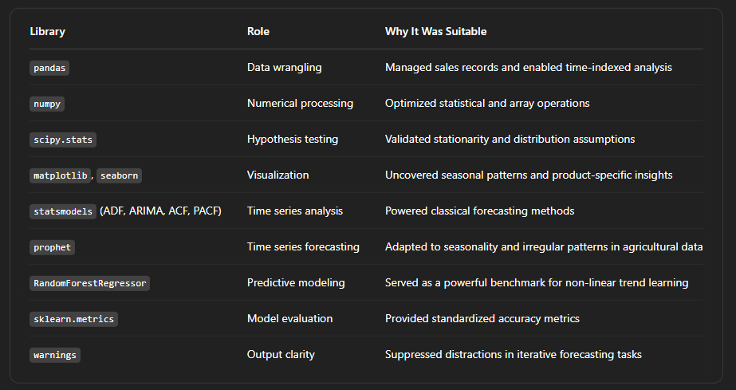

🎯 **Takeaway**:  
This project bridges the gap between **agriculture and AI**, driving **data-informed decisions** that reduce waste and improve logistics. The tech stack blended **classical time series models** with **modern machine learning** to achieve optimal accuracy and reliability across diverse products.

📌 This project will be a major reference in both my **professional portfolio** and **academic applications**.

👨‍🌾📉 If you're working on agritech, time series forecasting, or data-driven logistics, let's connect and explore collaboration!

#DataScience #Forecasting #Agritech #MachineLearning #Python #TimeSeriesAnalysis #AgriculturalInnovation #Prophet #ARIMA #RandomForest #pandas #seaborn #AMDARI #ALX #CasmirAnyaegbu #AIforGood #DemandForecasting #SupplyChain